# **Front-End UI/UX Mini Project**

## **Project Submission Document**

### 

**Project Title:**

# Responsive Promotional Website for Deafheaven

**Submitted By:**

| **Team Member** | **Roll Number** | **College E-mail ID** |
| --- | --- | --- |
| Davis Joby | 2460355 | davis.joby@btech.christuniversity.in |
| Jom Donson | 2460383 | jom.donson@btech.christuniversity.in |
| Cyriac Sebastian | 2460352 | cyriac.sebastian@btech.christuniversity.in |

**Course:** UI/UX Design Fundamentals

**Instructor Name:** Narendran

**Institution:** Christ University

**Date of Submission:** 11/08/2025

### **Abstract**

This project involves designing and developing a promotional website for *Deafheaven*, an American post-metal band known for blending elements of black metal, shoegaze, and post-rock. The aim is to create a visually striking platform where fans can explore the band’s profile, upcoming events, albums, and gallery. Using only **HTML5** and **CSS3**, the website incorporates a bold, high-contrast aesthetic consistent with Deafheaven’s atmospheric and intense musical style. The layout is structured using Flexbox and CSS Grid, ensuring an engaging visual presentation and smooth navigation. This static site serves as an artistic, band-branded hub for fan interaction without requiring scripting or backend integration.

### **Objectives**

* Design a user-friendly interface with a dark, atmospheric theme that reflects Deafheaven’s style.
* Develop a fully structured multi-section layout using only HTML and CSS.
* Implement Flexbox and Grid for organizing visual and informational sections.
* Maintain consistent branding aligned with the band’s real-world image.

### **Scope of the Project**

* Focused entirely on **front-end design** with HTML5 and CSS3.
* No JavaScript or backend integration included.
* Optimized for desktop viewports.
* Visual style inspired by Deafheaven’s album art and live performances.
* Uses only open-source resources for fonts, images, and code.

### **Tools & Technologies Used**

| **Tool/Technology** | **Purpose** |
| --- | --- |
| HTML5 | Markup and content structure |
| CSS3 | Styling and layout management |
| VS Code | Code editor |

### 

### **HTML Structure Overview**

* Semantic tags: <header>, <nav>, <main>, <section>, <footer>
* Sections: **Hero, About, Tour Dates, Gallery**
* Navigation menu: <ul> with anchor links to page sections.
* Gallery and album showcases implemented with CSS Grid for structured layouts.

### 

### **CSS Styling Strategy**

* External CSS file (style.css) with section-based organization.
* Techniques:  
  + Flexbox for hero section and content arrangement.
  + CSS Grid for gallery and album layouts.
  + CSS Variables for theme customization.
  + Hover effects for interactive elements.
* Dark and high-contrast color palette inspired by Deafheaven’s branding.

### 

### **Key Features**

| **Feature** | **Description** |
| --- | --- |
| Responsive Design | Adapts to different screen sizes |
| Bold Typography & Theme | Strong, atmospheric fonts with high-contrast visuals |
| Gallery Section | Grid layout with hover effects for images |

### 

### **Challenges Faced & Solutions**

| **Challenge** | **Solution** |
| --- | --- |
| Maintaining text readability on dark, textured backgrounds | Applied semi-transparent overlays to text blocks |
| Aligning elements in a complex layout | Used Flexbox and CSS Grid instead of floats |
| Ensuring consistent image display | Applied object-fit: cover for uniform cropping |

### 

### **Outcome**

* Created a cohesive, visually impactful website for Deafheaven.
* Displayed multimedia content without any JavaScript or backend dependencies.
* Strengthened design skills in layout composition and music-themed UI aesthetics.

### 

### **Future Enhancements**

* Integrate JavaScript for music playback and interactive content.
* Add smooth section transitions and animations.
* Include backend integration for fan message submissions.
* Implement a light/dark mode toggle for alternate viewing styles.

### 

### 

### 

### 

### 

### 

### **Sample Code**

**HTML:**

| <div class="hero">  <label for="sidebar-active" class="open-sidebar-button">  <img class="deafheaven-sidebar-logo" src="images/logos/logo.png" alt="logo">  </label>  <div class="main-logo">  <a href="index.html"><img class="deafheaven-text" src="images/logos/deafheaven.png" alt="DeafHeaven"></a>  </div>  <div class="right"></div>  </div> |
| --- |

**CSS:**

| .hero {  display: flex;  align-items: center;  justify-content:space-between;  background-color: black;  position: -webkit-sticky;  position: sticky;  top: 0;  z-index: 9;  } |
| --- |

### 

### **Output:**

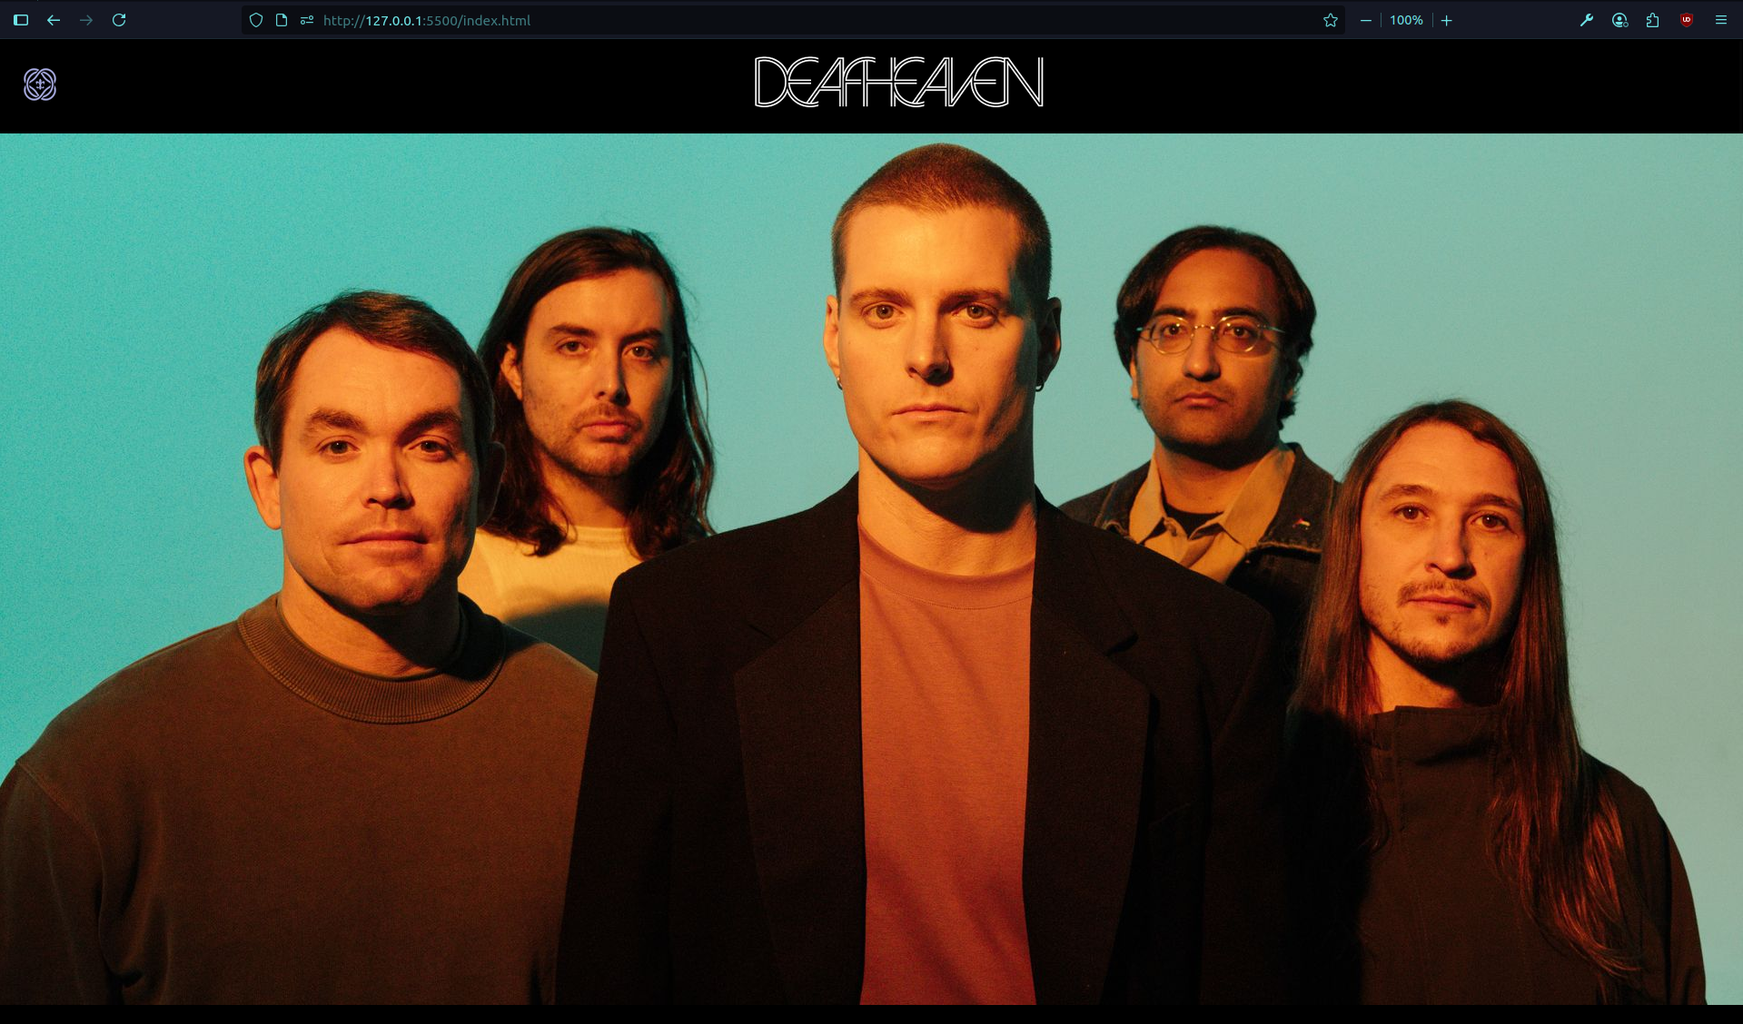

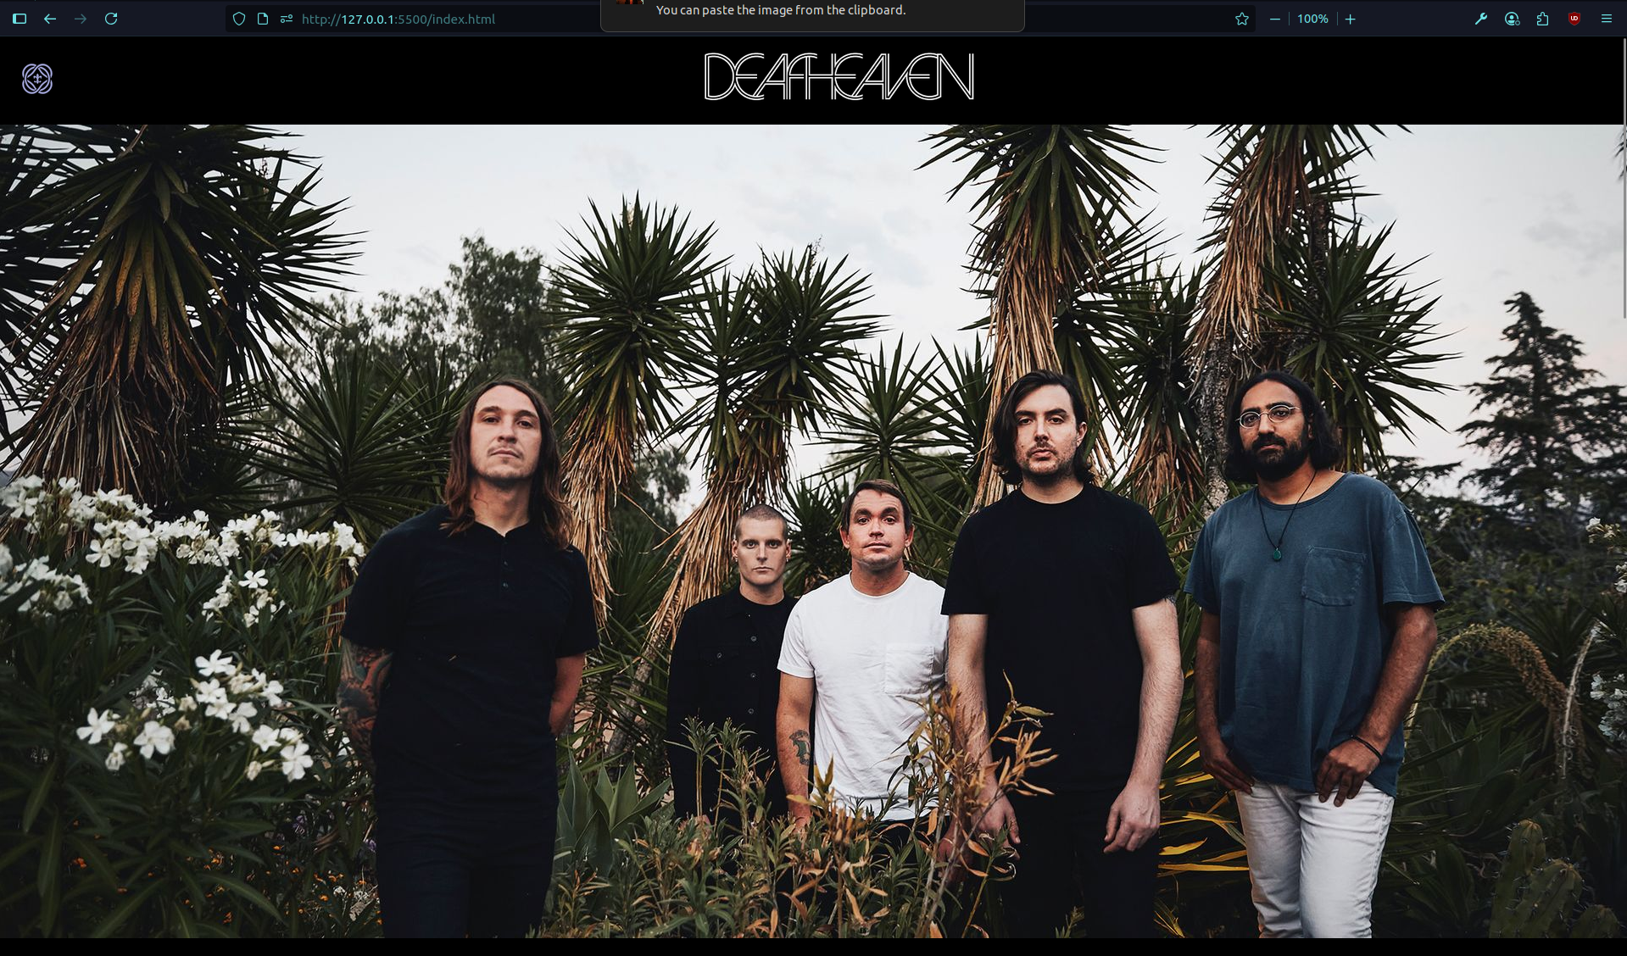

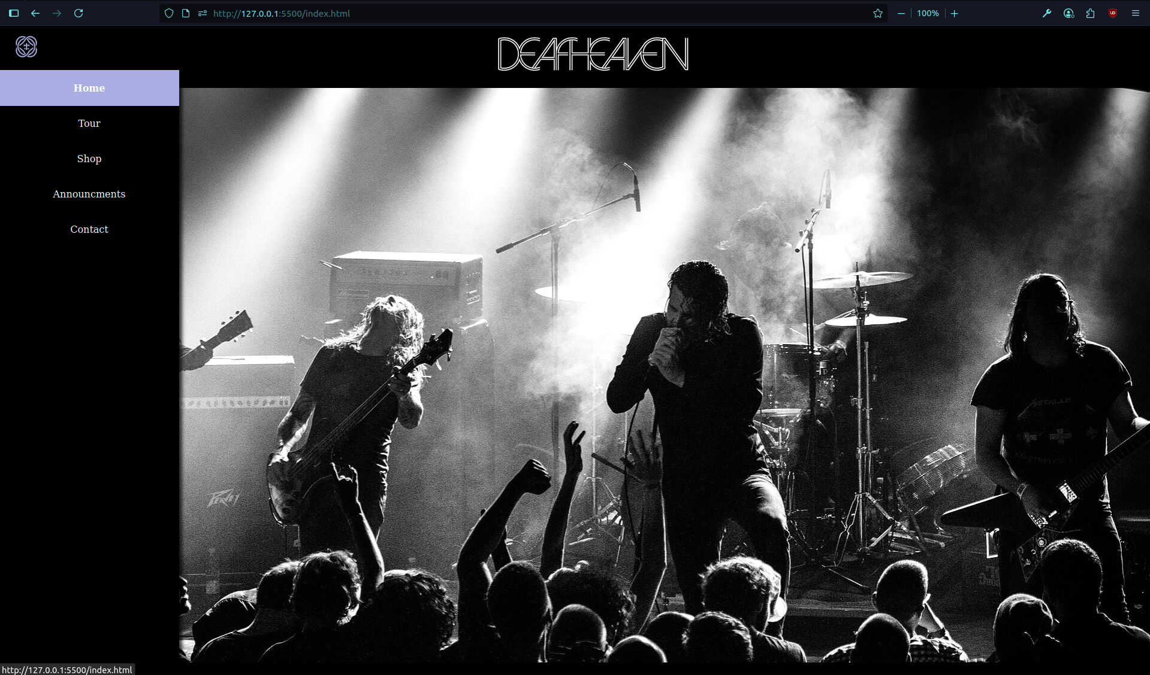

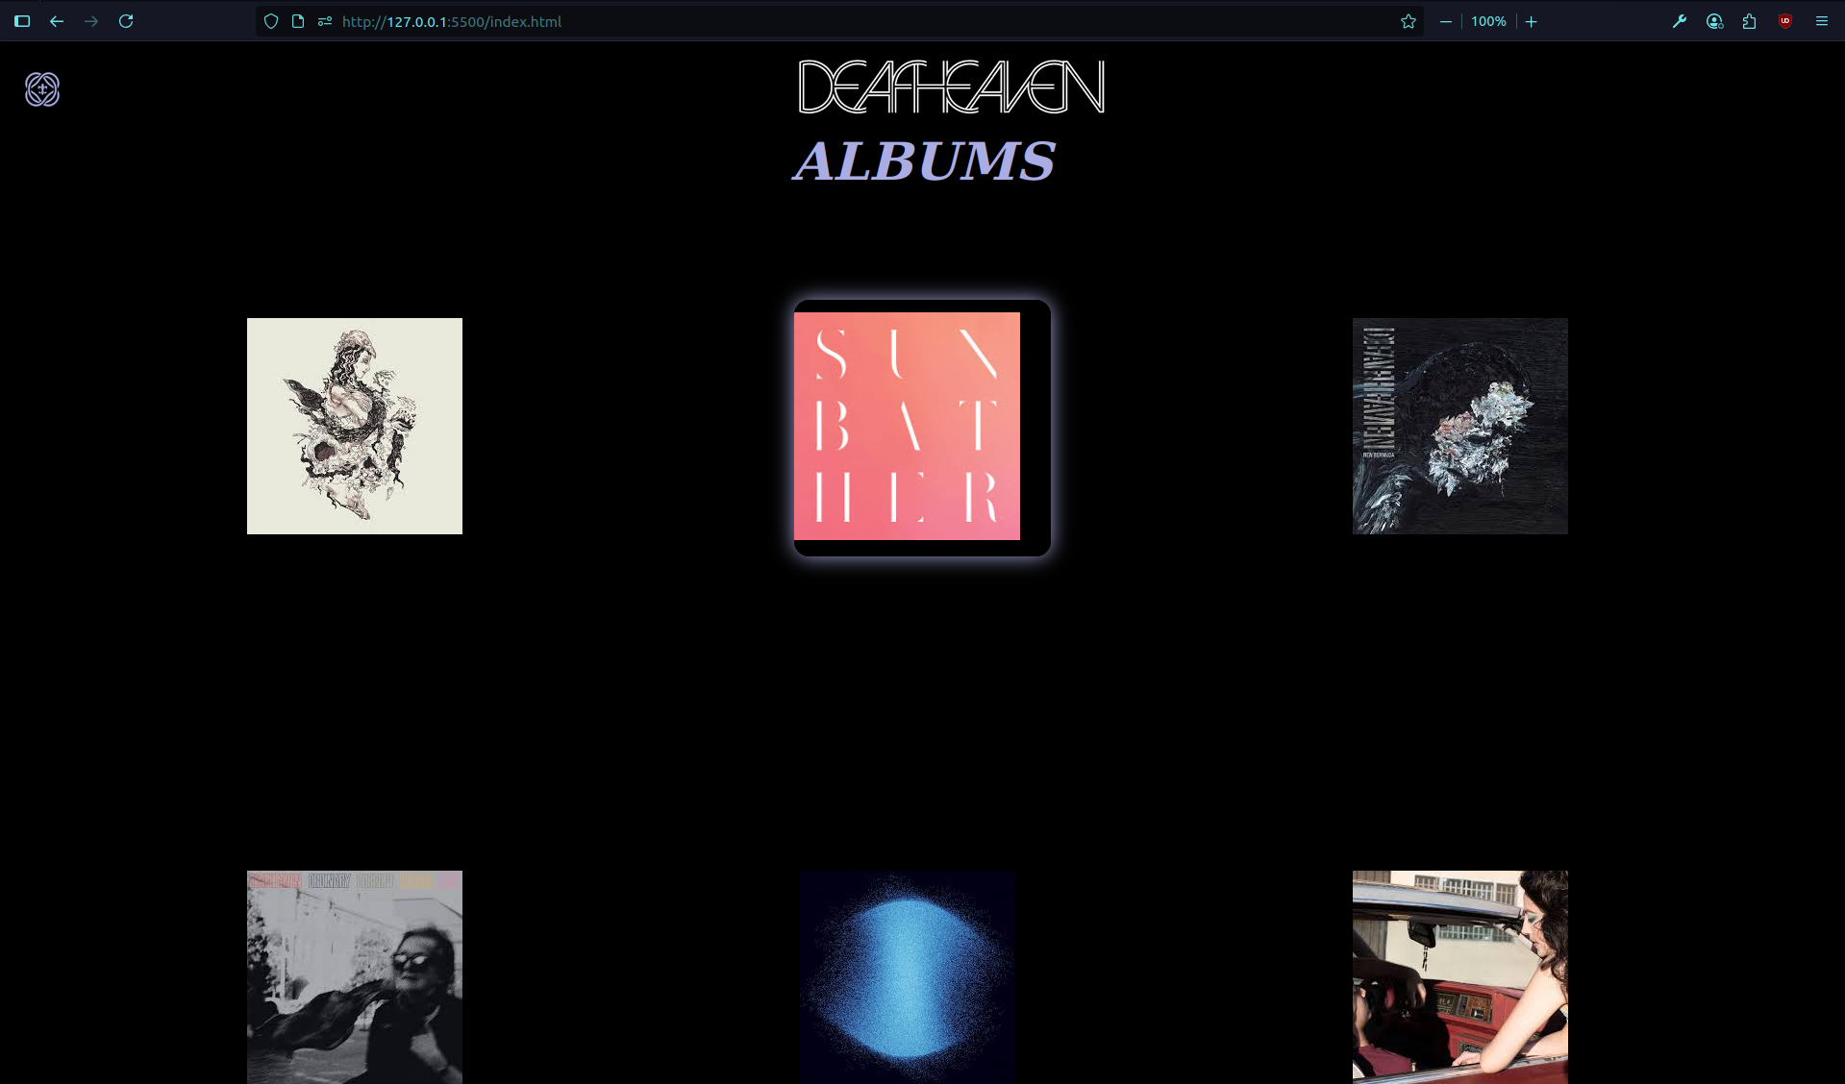

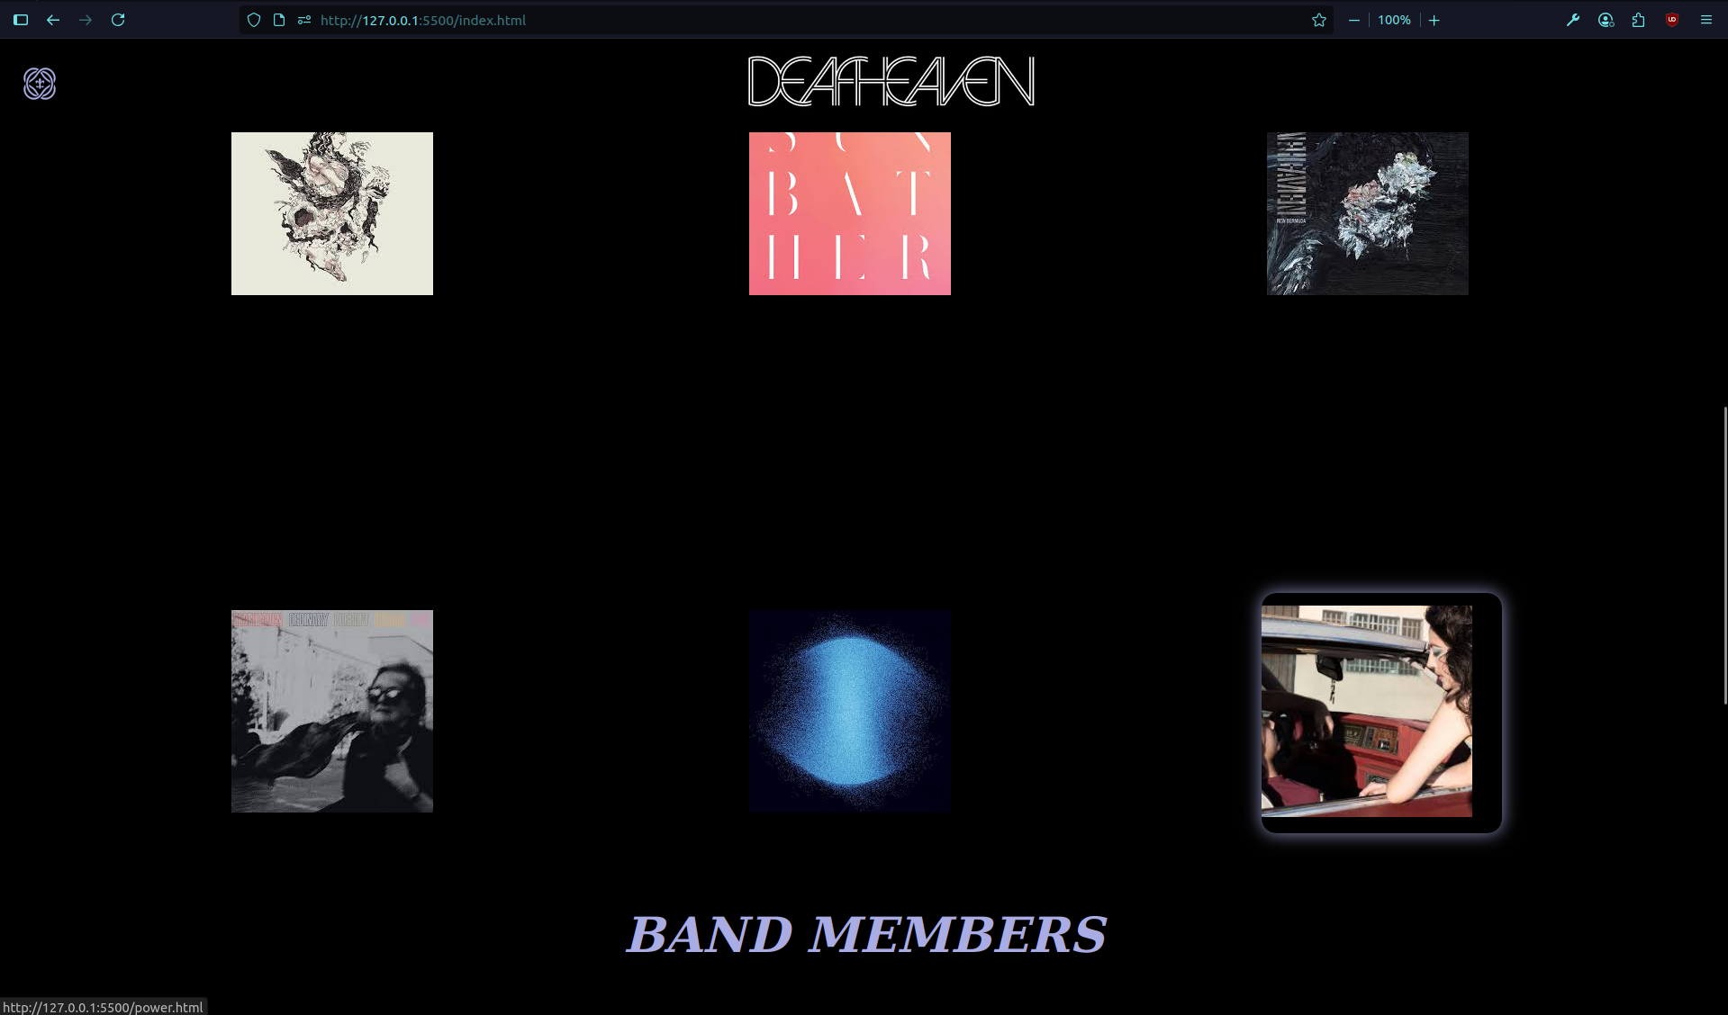

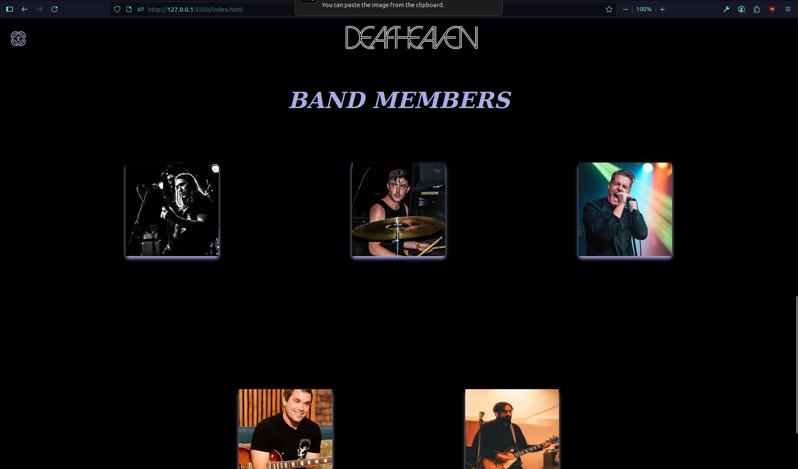

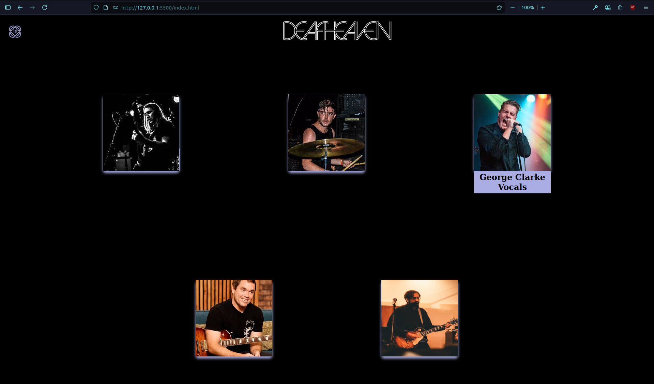

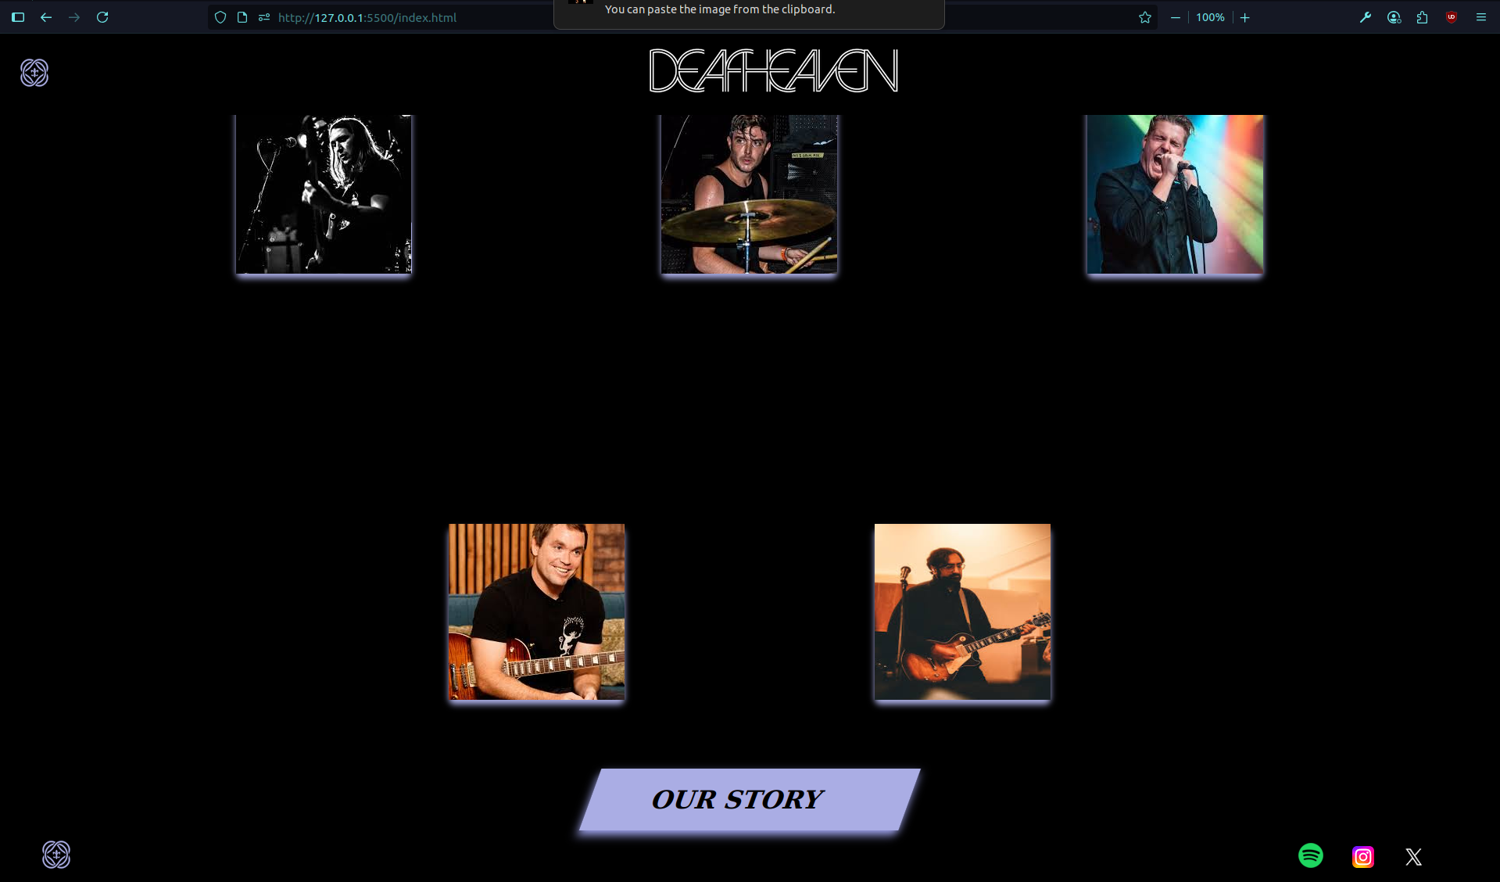

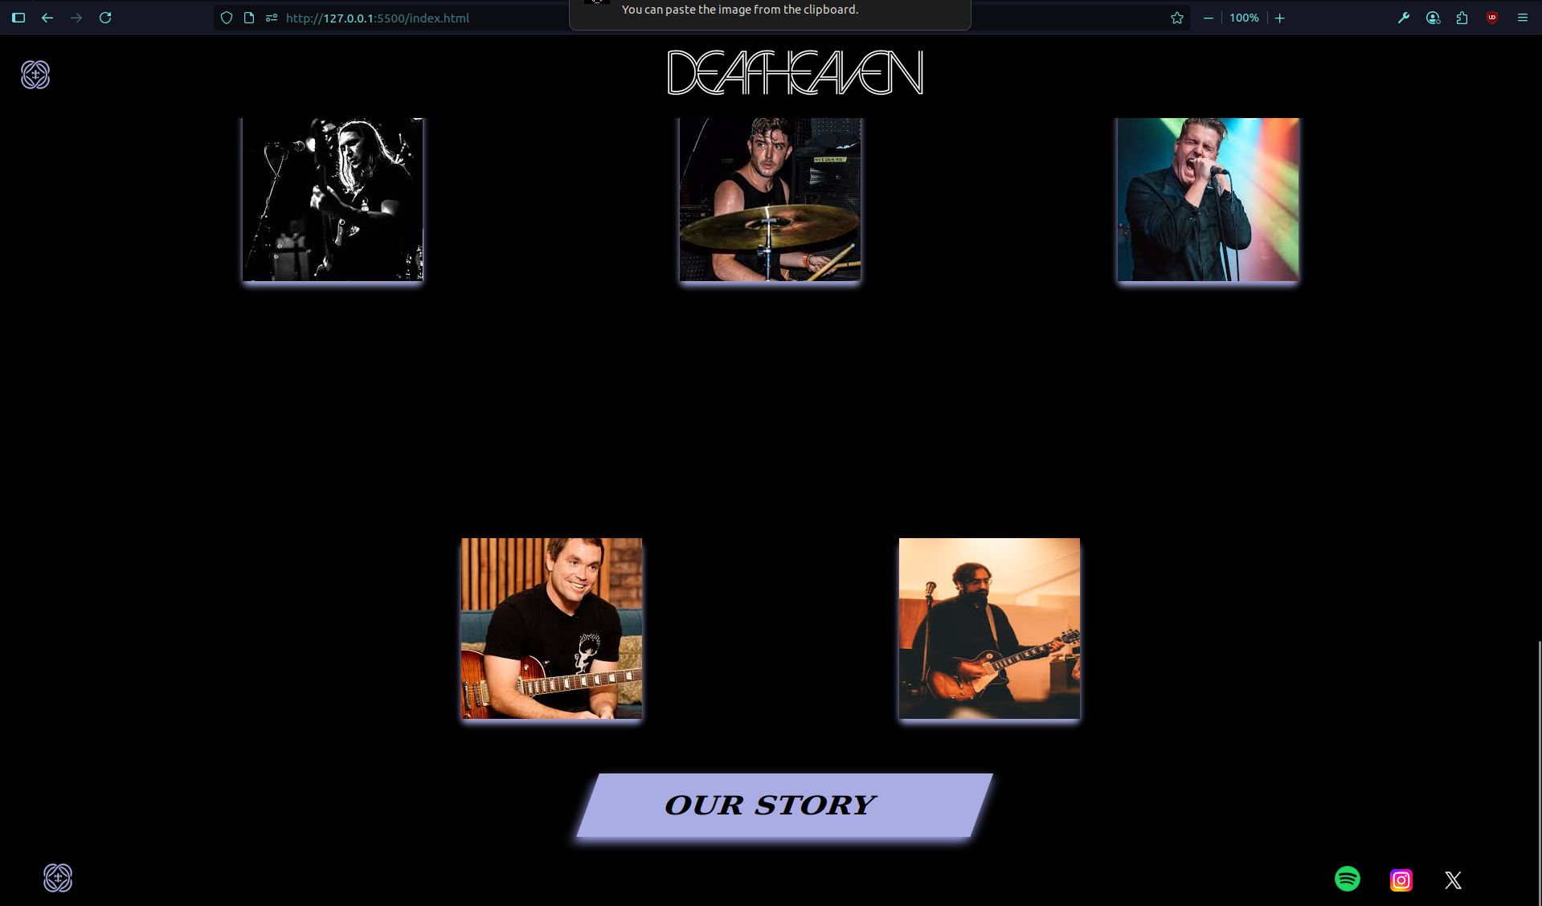

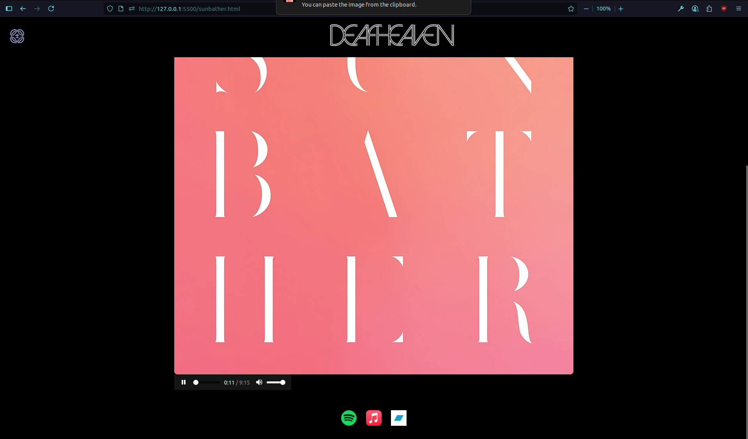

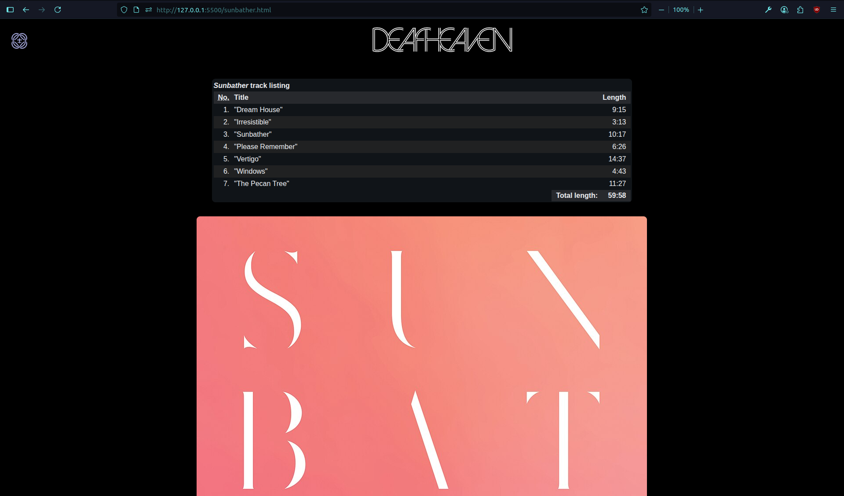

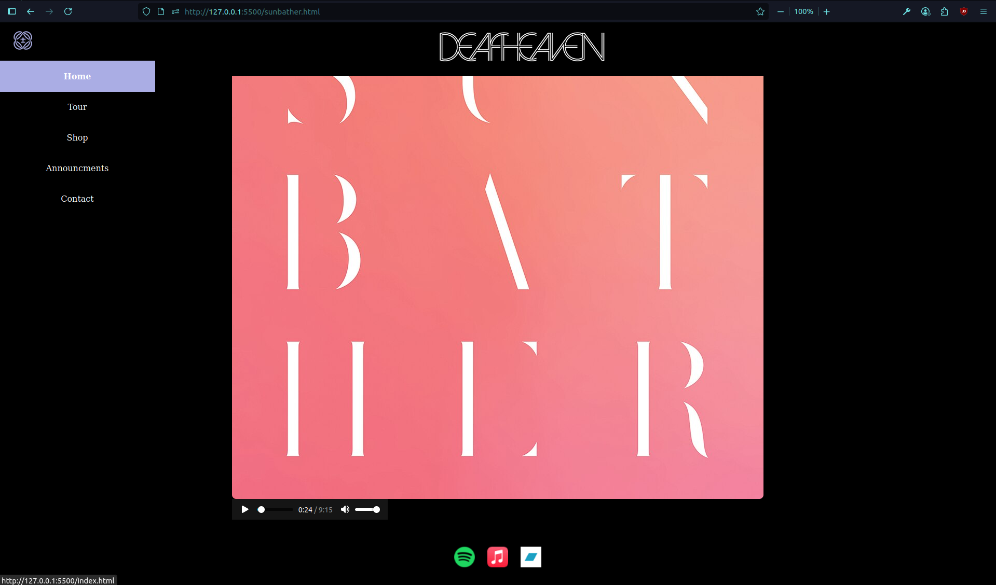

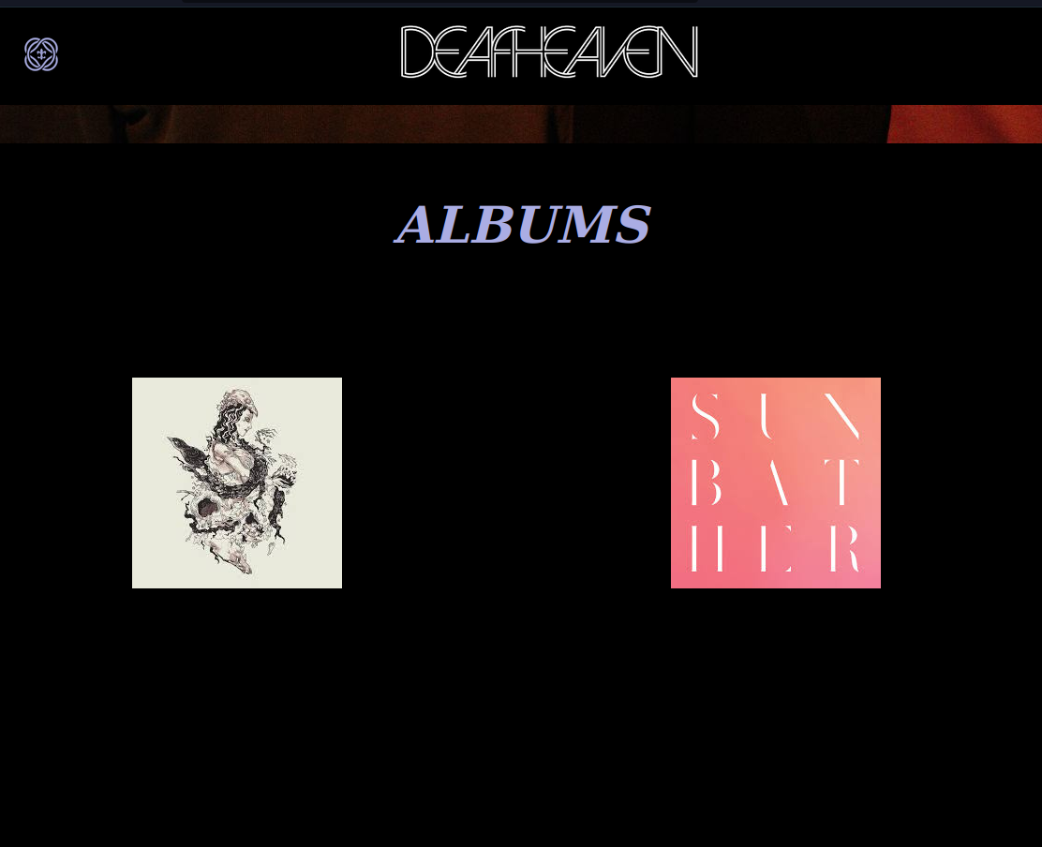

### **Conclusion**

This project successfully delivered a static promotional website for Deafheaven using HTML5 and CSS3. It captured the essence of the band’s atmospheric and intense musical identity through visual design choices and layout structuring. The project strengthened practical skills in UI/UX design, focusing on cohesive theme application without relying on interactive scripts.

### 

### **References**

* L&T LMS:<https://learn.lntedutech.com/Landing/MyCourse>
* W3Schools:<https://www.w3schools.com>
* CSS-Tricks:<https://css-tricks.com>